Class exercise 2-1: creating a simple page

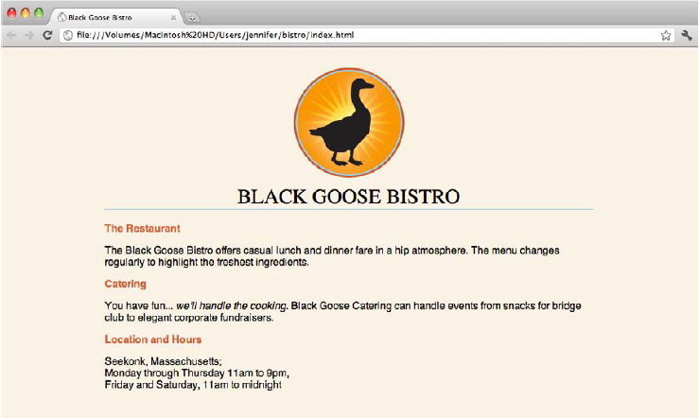

## Step1 Entering content

1. Type the content below for the home page into the new document in your text editor. Copy it exactly as you see it here, keeping the line breaks the same for the sake of playing along.

*Black Goose Bistro*

*The Restaurant*

*The Black Goose Bistro offers casual lunch and dinner fare in a hip atmosphere. The menu changes regularly to highlight the freshest ingredients.*

*Catering Services*

*You have fun... we'll do the cooking. Black Goose catering can handle events from snacks for bridge club to elegant corporate fundraisers.*

*Location and Hours*

*Seekonk, Massachusetts;*

*Monday through Thursday 11am to 9pm, Friday and Saturday, 11am to midnight*

2. Save html file. Create a new folder, name the new folder *bistro*, and save the text file as index.html in it.

3. Just for kicks, let’s take a look at index.html in a browser.

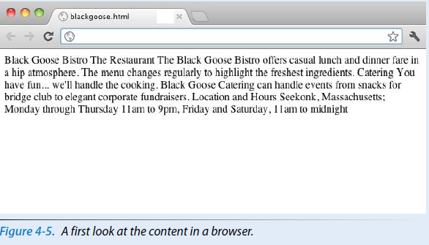

## Step 2:Give the Document Structure

1. Open the newly created document, *index.html*, if it isn't open already.

2. Start by adding the HTML5 DOCTYPE declaration:

<!DOCTYPE html>

3. Put the entire document in an HTML root element by adding an **<html>** start tag at the very beginning and an end **<html>** tag at the end of the text.

4. Next, created the document head that contains the title for the page. Insert **<head>** and **</head>** tags before the content. Within the head element, add information about the character encoding **<meta charset="utf-8">**, and the title,

"Black Goose Bistro", surrounded by opening and closing **<title>** tags.

*The correct terminology is to say that the* **title** *element is nested within the*

**head** *element.*

5. Finally, define the body of the document by wrapping the content in <body> and </body> tags. When you are done, the source document should look like this (the markup is shown in color to make it stand out):

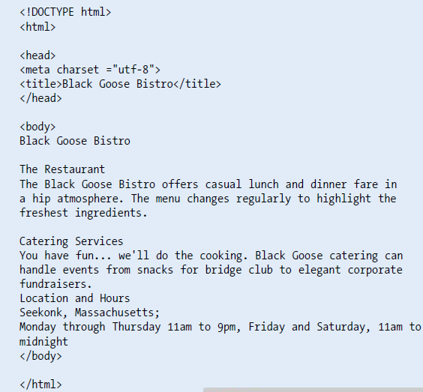

6. Save the document in the bistro directory, so that it overwrites the old version. Open the file in the browser or hit "refresh" or "reload" if it is open already. The following Figure shows how it should look now.

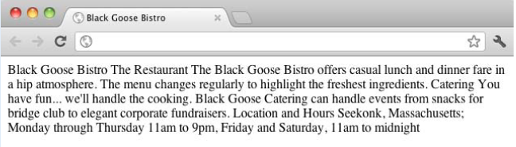

## Step 3: Defining text elements

1. Open the document *index.html* in your text editor, if it isn’t open already.

2. The first line of text, “Black Goose Bistro,” is the main heading for the page, so we’ll mark it up as a Heading Level 1 (**h1**) element. Put the opening tag, **<h1>**, at the beginning of the line and the closing tag, **</h1>**, after it, like this:

<h1>Black Goose Bistro</h1>

3. Our page also has three subheads. Mark them up as Heading Level 2 (**h2**) elements in a similar manner. I’ll do the first one here; you do the same for “Catering” and “Location and Hours”. <h2>The Restaurant</h2>

4. Each **h2** element is followed by a brief paragraph of text, so let’s mark those up as paragraph (**p**) elements in a similar manner. Here’s the first one; you do the rest.

<p>The Black Goose Bistro offers casual lunch and dinner fare in a hip atmosphere. The menu changes regularly to highlight the freshest ingredients.

</p>

5. Finally, in the Catering section, I want to emphasize that visitors should just leave the cooking to us. To make text emphasized, mark it up in an emphasis element (**em**) element, as shown here.

<p>You have fun... <em>we'll handle the cooking </em>. Black Goose Catering can handle events

from snacks for bridge club to elegant corporate fundraisers.</p>

6. Now that we’ve marked up the document, let’s save it as we did before, and open (or refresh) the page in the browser. You should see a page that looks much like the one in Figure 4-9. If it doesn’t, check your markup to be sure that you aren’t missing any angle brackets or a slash in a closing tag.

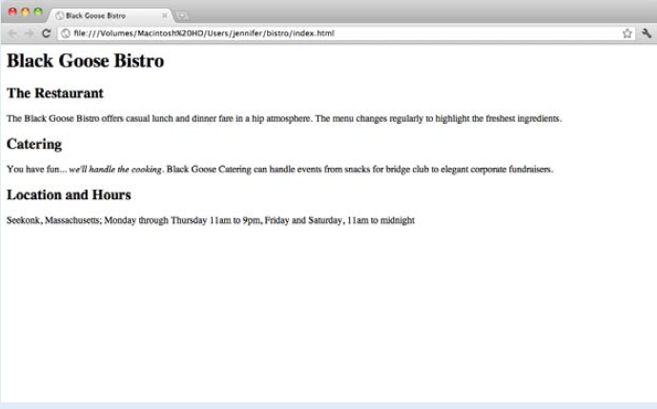

*Figure 4-9. The home page after the content has been marked up with HTML elements.*

## Step 4:add an image

1. If you’re working along, the first thing you’ll need to do is get a copy of the image file on your hard drive so you can see it in place when you open the file locally. Name the file *blackgoose.png*. Be sure to save it in the *bistro* folder with *index.html*.

2. Once you have the image, insert it at the beginning of the first-level heading by typing in the **img** element and its attributes as shown here:

<h1><img src="blackgoose.png" alt="Black Goose logo">Black Goose

Bistro</h1>

The **src** attribute provides the name of the image file that should be inserted, and the **alt** attribute provides text that should be displayed if the image is not available. Both of these attributes are required in every **img** element.

3. I’d like the image to appear above the title, so lets add a line break (**br**) after the **img** element to start the headline text on a new line.

<h1><img src="blackgoose.png" alt="Black Goose logo"><br>Black

Goose Bistro</h1>

4. Let’s break up the last paragraph into three lines for better clarity. Drop a **<br>** tag at the spots you’d like the line breaks to occur. Try to match the screenshot in Figure 4-14.

5. Now save *index.html* and open or refresh it in the browser window. The page should look like the one shown in Figure 4-14. If it doesn’t, check to make sure that the image file, *blackgoose.png*, is in the same directory as *index.html*. If it is, then check to make sure that you aren’t missing any characters, such as a closing quote or bracket, in the **img** element markup.

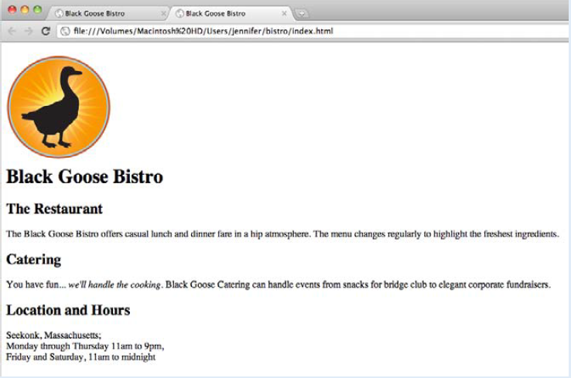

*Figure 4-14. The Black Goose Bistro page with the logo image.*

## Step 5: Adding a Style Sheet

1. Open *index.html* if it isn’t open already.

2. We’re going to use the **style** element to apply a very simple embedded style sheet to the page. (This is just one of the ways to add a style sheet; the others are covered in The **style** element is placed inside the **head** of the document. Start by adding the **style** element to the document as shown here:

<head>

<meta charset="utf-8">

<title>Black Goose Bistro</title>

<style>

</style>

</head>

3. Now, type the following style rules within the **style** element just as you see them here. Don’t worry if you don’t know exactly what is going on (although it is fairly intuitive).

<style>

body {

background-color: #faf2e4;

margin: 0 15%;

font-family: sans-serif;

}

h1 {

text-align: center;

font-family: serif;

font-weight: normal;

text-transform: uppercase;

border-bottom: 1px solid #57b1dc;

margin-top: 30px;

}

h2 {

color: #d1633c;

font-size: 1em;

}

</style>

4. Now it’s time to save the file and take a look at it in the browser. It should look like the page in Figure 4-15. If it doesn’t, go over the style sheet code to make sure you didn’t miss a semicolon or a curly bracket.

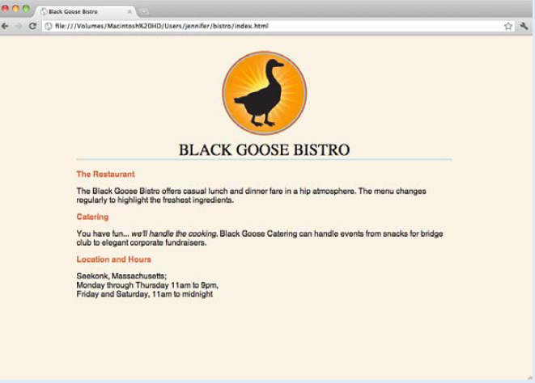

*Figure 4-15. The Black Goose Bistro page after CSS style rules have been applied.*